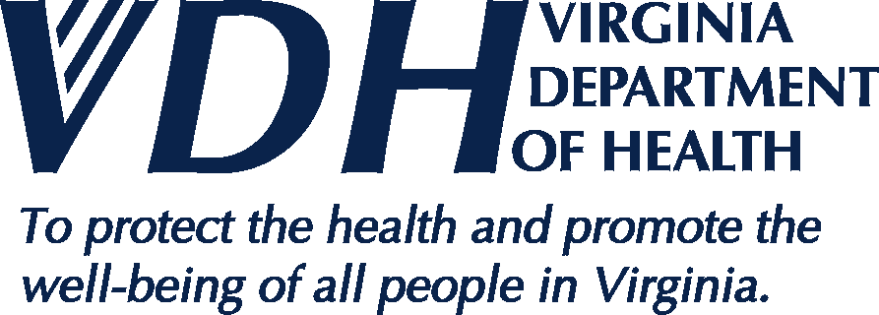 | News Release
109 Governor Street, Richmond, Virginia 23219 ● www.vdh.virginia.gov

FOR IMMEDIATE RELEASE March 24, 2020
For More Information, Contact:
Robert Parker, public information officer, Western Region, robert.parker@vdh.virginia.gov

NEW RIVER HEALTH DISTRICT CONFIRMS ITS FIRST CASE OF COVID-19

(CHRISTIANSBURG, Virginia) -- The New River Health District announced today its first confirmed case of COVID-19 in a resident of the district. The patient is a female in her 20s, and lives in Radford. She is self-isolating, with no known exposures to the public. To protect patient privacy, no further information will be provided.

“We’ve been preparing for this news for more than two weeks,” said Noelle Bissell, M.D., director, New River Health District. “The Virginia Department of Health and our partners in health and public safety have been in constant contact to develop effective measures to keep New River Valley residents safe and well. Now, more than ever, it’s important for everyone to practice personal public health precautions, primarily for hand and surface hygiene and social distancing. These are the most effective ways to minimize the spread of illness and keep yourself and those around you well.”

“For each confirmed case of any communicable illness that is required to be reported, the VDH identifies potential contacts, assesses their risk of exposure and recommends appropriate public health and medical measures,” said Dr. Bissell.

Most patients with COVID-19 have mild to moderate symptoms, which include fever, cough and shortness of breath. Symptoms most often appear within 14 days of being exposed to an infectious person. COVID-19 spreads primarily through respiratory droplets produced when an infected person coughs or sneezes. In a small number of patients, COVID-19 can lead to more severe illness, including death, particularly among those who are older or those who have chronic medical conditions, like diabetes, heart or lung disease or compromised immune systems.

To lower the risk of spreading respiratory infections, including COVID-19, the Virginia Department of Health encourages everyone to:
- Stay home when you are sick;
- Avoid contact with sick people;
- Cover your mouth and nose with a tissue or your sleeve (not your hands) when coughing or sneezing;
- Wash your hands often with soap and water for at least 20 seconds; use an alcohol-based hand sanitizer if soap and water are not available;
- Avoid touching your eyes, nose, and mouth;
- Clean and disinfect frequently touched objects and surfaces;
- If you are experiencing symptoms, call your doctor;
- Practice social distancing. Maintain at least six feet of space between yourself and other individuals when out in public; and
- Avoid crowds of more than 10 people.

For more information, call the New River Health District’s COVID-19 public health call center at 540-267-8240. Hours are Monday through Friday, 8 a.m. to 8 p.m.; Saturday, 8 a.m. to noon and Sunday, noon to 4 p.m. After hours, leave a message. For the most accurate and up-to-date information online, visit www.vdh.virginia.gov/new-river, www.nrvroadtowellness.com, www.vdh.virginia.gov/coronavirus and www.cdc.gov/coronavirus.

NOTE: This case is not yet reflected in the VDH website dashboard, which is updated daily with cases recorded by 5 p.m. the evening before.

# # #

